GROUP PROJECT

SOFTWARE EVOLUTION & CONFIGURATION

**Hor Weng Liang**

**Muhammad Hazim bin Kamaruzzaman**

**Luqman Hakim bin Ahmad Tamrin**

**Siti Sarah binti Azmi**

**Siti Aishah binti Aminuddin**

**Adreen binti Mohd Affendy**

**Nur Aainaa binti Ismail**

SEMESTER 1 2017/2018

TEAM MEMBERS

# INTRODUCTION

## Github

GitHub is an open-source version control system created by Linus Trovalds. It is a place where developers can create an application or system, make constants changes on the code, release new version more than once and store the modifications in a central repository. GitHub also allows developers to easily collaborate as they can download new version of the software, make changes and upload the latest version of it. This way every developer can see the new changes, download and contribute.

## Cocomoo

Constructive Cost Model (COCOMO) is a procedural software cost estimation model developed by Barry W. Boehm which use to estimate size, effort and duration base on the cost of the software. COCOMO are divided into three mode which are

- Organic

“Small” teams with good experience that work less than rigid requirements

- Semi-detached

“Medium” team that are got mixed experience working with a mix rigid and less than rigid requirements

- Embedded

Developed within set of “tight” limitations. It is also a combination of organic and semi-detached between hardware, software and operational calculation.

The basic COCOMO equations take the form

Effort Applied (E) = ab(KLOC)bb [ [man-months](https://en.wikipedia.org/wiki/Man-month) ]

Development Time (D) = cb(Effort Applied)db [months]

People required (P) = Effort Applied / Development Time [count]

where, KLOC is the estimated number of delivered lines (expressed in thousands ) of code for project. The coefficients *ab*, *bb*, *cb* and *db* are given in the following table (note: the values listed below are from the original analysis, with a modern reanalysis[[4]](https://en.wikipedia.org/wiki/COCOMO#cite_note-4) producing different values):

# TOOL ASSESSMENT

Sublime text

Sketch (UI design)

Atom (coding develop)

Github desktop & gitbash

# CHANGED PROPOSED

# 

1. Add back button

Can back to previous page when click back button on browser

When click on ‘Calculate Cocomo’ button without entering any input, this pop-up message appear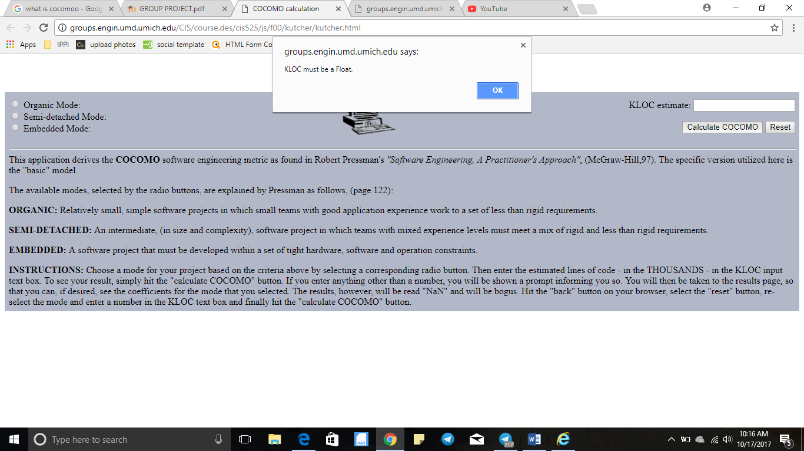

When click ‘Ok’ on the pop-up message, this happen although without entering any input.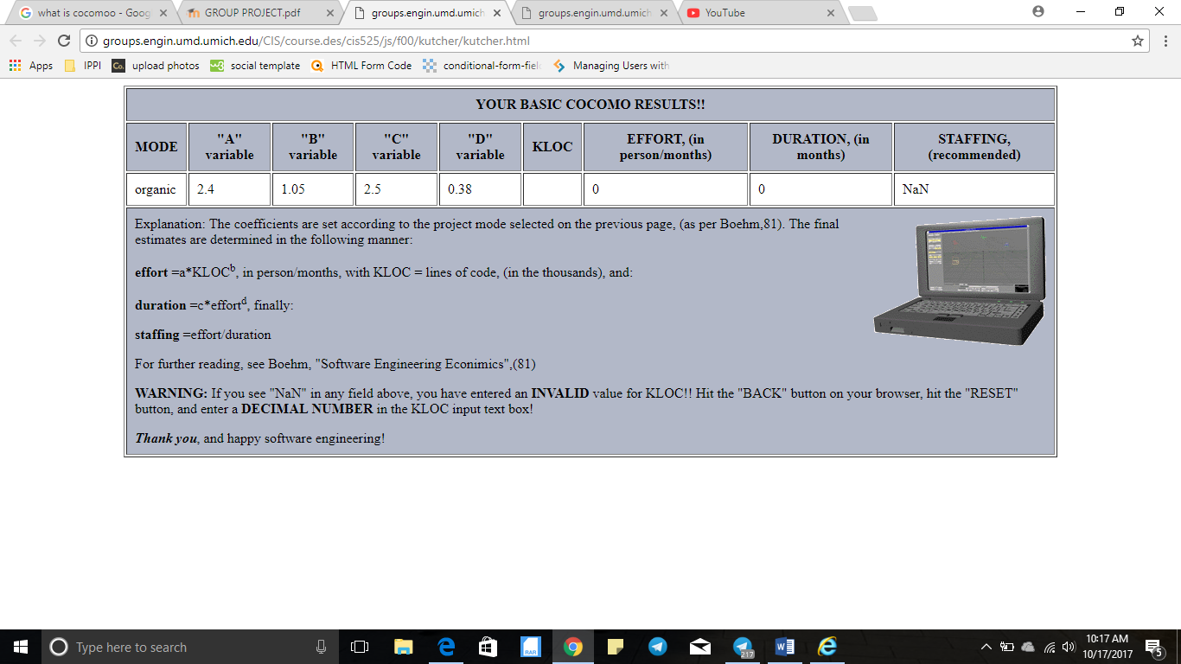

# GITHUB RECORD

